Highfields Academy
Literacy Information Leaflet
Year 1
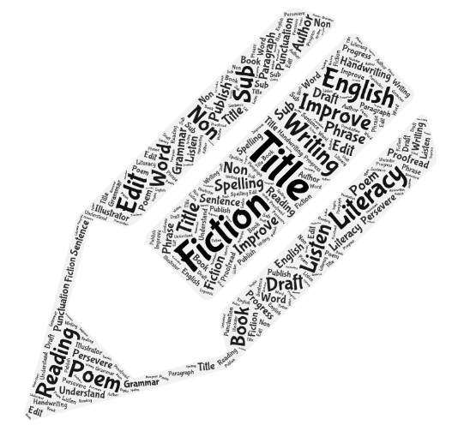
Year 1 End of Year Expectations

Reading
Word Reading
- Apply phonic knowledge and skills as the route to decode words
- Respond speedily with the correct sound to graphemes (letters or groups of letters) for all 40+ phonemes including (where applicable) alternative sounds for graphemes
- Read accurately by blending the sounds in words that contain the graphemes taught so far
- Read words containing common exception words, noting unusual correspondences between spelling and sound and where these occur in the word
- Read words containing taught GPSs and -s, -es, -ing, -ed, -ed and -est endings
- Read other words of more than one syllable that contain taught GPCs
- Read words with contractions e.g. I’m, I’ll, didn’t, and understand that the apostrophe represents the omitted letter (s)
- Read aloud books, accurately, that are consistent with their developing phonic knowledge and that do not require them to use other strategies to work out words
- Reread these books to build up fluency and confidence in word reading
Comprehension
Develop pleasure in reading, motivation to read, vocabulary and understanding by:
- Listening to, discussing and expressing views about a wide range of contemporary and classic poetry, stories and non-fiction at a level beyond that at which they can read independently
- Being encouraged to link what they read or hear to their own experiences
- Becoming very familiar with key stories, fairy stories and traditional tales, retelling them and considering their particular characteristics
- Recognising and joining in with predictable phrases
- Learning to appreciate rhymes and poems, and to recite some by heart
- Discussing word meaning, linking new meaning to those already know.
Understand both the books they can already read accurately and fluently, and those that they listen to by:
- Drawing on what they already know or on background information and vocabulary provided by the teacher
- Checking that the text makes sense to them as they read, and correcting inaccurate reading
- Discussing the significance of the title and events
- Making inferences on the basis of what is being said and done
- Predicting what might happen on the basis of what has been read so far
- Participate in discussion about what is read to them, taking turns and listening to what others say
- Explain clearly their understanding of what is read to them

Year 1 End of Year Expectations
Writing
Transcription
- Spell words containing each of the 40+ phonemes already taught
- Spell some common exception words
- Name the days of the week
- Sound the letters of the alphabet
- Say the letters of the alphabet in order
- Use letter names to distinguish between alternative spellings of the same sound
- Use the spelling rule for adding -s or -es (Clap Clap rule)
- Use the prefix un-
- Use the suffixes -ing, -ed, -er and -est where no change is needed in the spelling of the root word
- Write from memory simple sentences dictated by the teaching that include words using the GPCs and common exception words taught so far
Composition
Write sentences by:
- Saying out loud what they are going to write about
- Composing a sentence orally before writing it
- Sequencing sentences to form short narratives
- Re-reding what they have written to check that it makes sense
- Discuss what they have written with the teacher or other pupils
- Read their writing aloud, clearly enough to be heard by their peers and the teacher

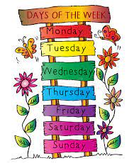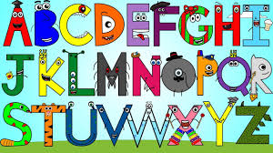
Year 1 Grammar and Terminology
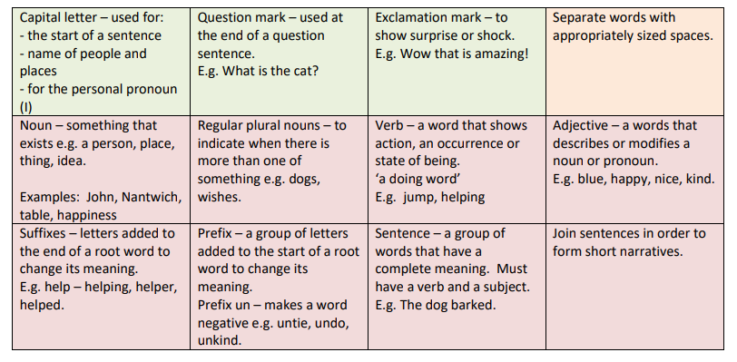
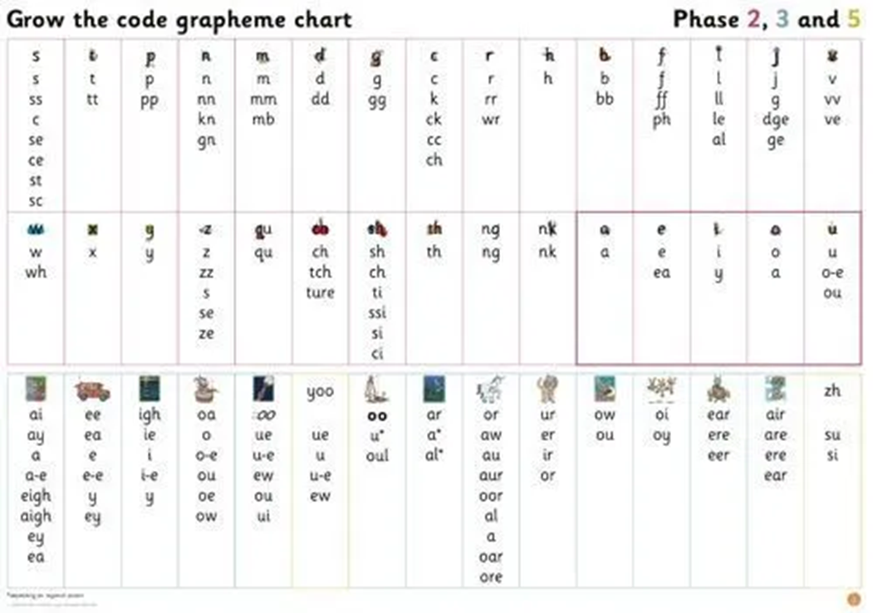

Year 1 Common Exception Words
By the end of Year 1, children should be able to spell these words correctly and use them in their independent writing appropriately.
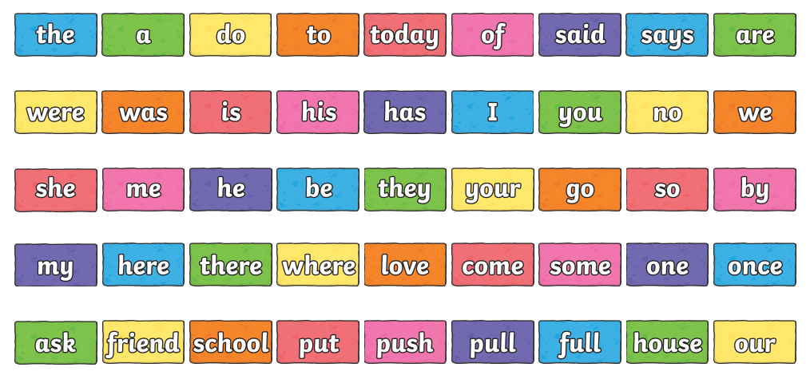
Practise saying these words in sentences, reading and spelling them.
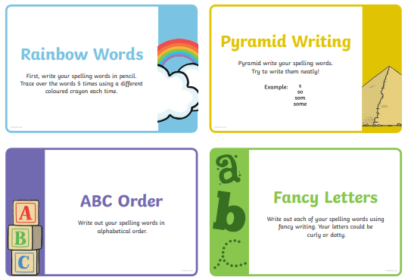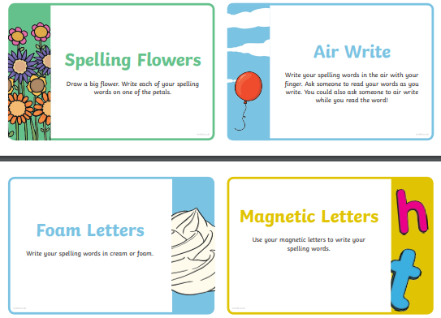
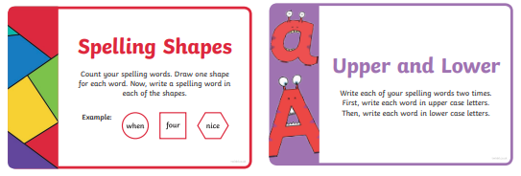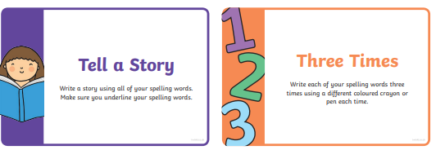

Handwriting expectations in Year 1
Pupils should be taught to:
- sit correctly at a table, holding a pencil comfortably and correctly
- begin to form lower-case letters in the correct direction, starting and finishing in the right place – using a cursive style
- form capital letters
- form digits 0-9
- understand which letters belong to which handwriting ‘families’ (letters that are formed in similar ways) and to practise these
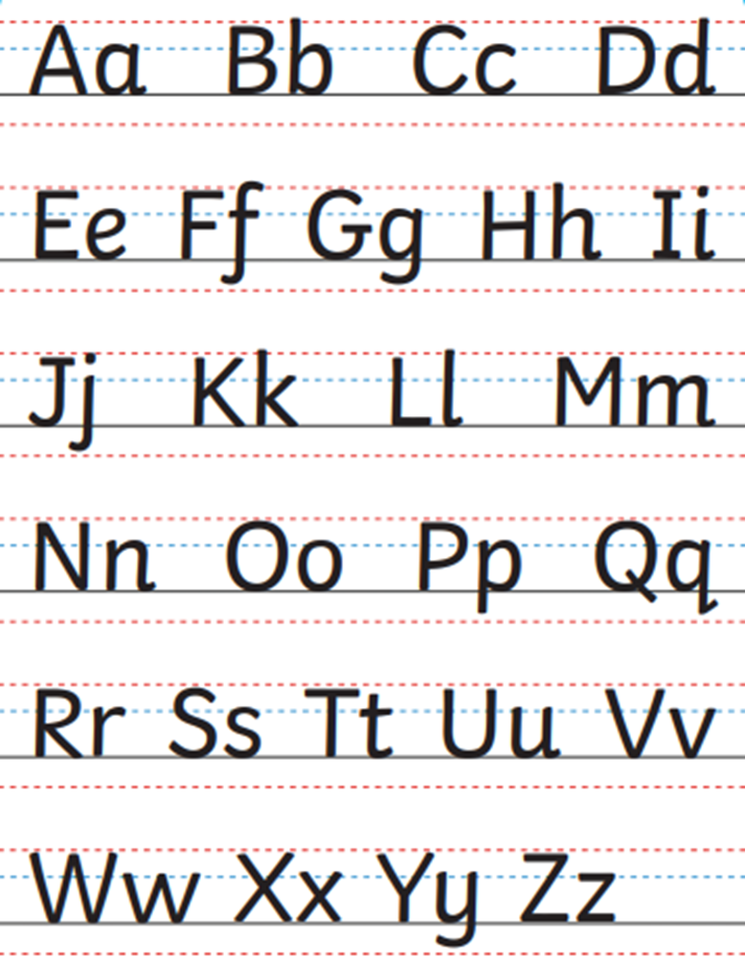

Supporting your child at home
There is so much that you can do in your everyday life to support your child’s English skills. Words are everywhere, so encourage your child to become a ‘word spotter’ and soon they will be reading without even realising!
Reading Listen to your child daily if possible so that they can become fluent readers. While reading, focus on questioning, retelling and predicting.
Your child will be allocated a phonic read using the Collins online library. This book will contain words that use the phonic knowledge your child has been taught. It should be an easy read for them. They will also be given a free reading book. This may contain unfamiliar words.
Strategies to help your child to read unfamiliar words:
- Use the pictures (don’t cover them up) as they can help your child to predict unfamiliar words in a text.
- Sound out words and encourage them to look for digraphs (two letters one sound) e.g. sh, th, ee, and trigraphs (three letters one sound) e.g. tch, dge.
- Break up larger words by looking for smaller words within them e.g. yesterday, sandpit, lunchbox.
- Read on past unfamiliar words and then discuss what would make sense, look right and sound right.
Strategies to help with comprehension:
- Ask your child specific questions – get them to go back to the part of the book where they can find the answer
- Get your child to ask you questions about the text.
- Ask your child to retell the story – ordering the events correctly.
- Ask your child to recall some key facts/explanations from a non-fiction text.
Writing Encourage your child to write for a range of purposes e.g. shopping lists, postcards, thank-you notes etc.
- Let your child spell words phonetically unless it is a common exception word.
- Help them to compose sentences orally before writing.
- Remind your child to start with a capital letter and end with a full stop.
- Encourage your child to use the cursive letters taught in class.
Word Games These can really help your child to build their vocabulary and increase their working memory for words.
- My Basket - each time you add an extra item to the basket. E.g. In my basket there is a loaf of bread. In my basket there is a loaf of bread and a bottle of milk. Etc.
- My grandmother’s cat – take turns adding adjectives to describe the cat e.g. fluffy, grey, grumpy, vicious, sneaky. You can change grandmother’s pet!
- How many words – think of as many words as possible to describe a person, place, building, food, toy, animal etc.
- Something starting with … - how many words can you think of that starts with your chosen letter?
Useful websites, apps and resources
NB: Some of these are free and some require a subscription.
https://www.bbc.co.uk/bitesize/subjects/zgkw2hv
http://www.crickweb.co.uk/ks1literacy.html
https://www.topmarks.co.uk/interactive.aspx?cat=43
http://www.primaryhomeworkhelp.co.uk/literacy/
https://www.ictgames.com/mobilePage/literacy.html
https://www.everyschool.co.uk/english-key-stage-1-words.html
Android and Apple also have a wide range of learning apps for you to access. Here is a selection of some well-known ones but they are constantly changing and expanding.
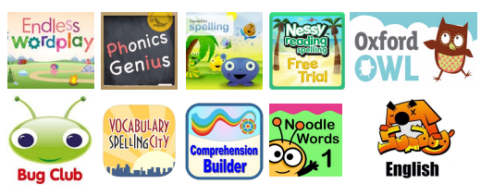
Finally, there are lots of practise books that you can buy from places such as WHSmith and Amazon. If you search online for Year 1 worksheets, there are also many free resources available.

